# **PRODUCT DESIGN**

State vocational and technical education board system design is comprised of several diagrams that give information about the design of the system. These include:

1. UML class diagram.
2. UML use Case diagram.
3. UML sequence diagram.
4. Database design diagram.

The following sections elaborate these concepts

## **UML CLASS DIAGRAM**

The UML (Unified Modelling Language) class diagram is as shown in the figure below.



*A diagram showing the class diagram for state vocational and technical education system*

As shown from the diagram above, the classes for the system are as elaborated below:

The school class consists the following member variables: Name (text), Location (text), Capacity (number) and Other Details (text).

The student class consists of the following member variables: Student No (text), Name (text), Personal Id (text), Gender (text), Other details (text), Course (Course) and School (School). Every student is assigned a course upon registration and every student belongs to a school.

The user class consists of the following member variables: User Name (text), Password (text), Other details (text) and School (School). Every user belongs to a school.

The course class consists of the following member variables: Course Name (text),

Other details (text) and School (School). Every course belongs to a school.

The alumni class consists of the following member variables: First name (text), Last name (text), Other details (text), Student (Student). Every school alumni were once a student.

The extra curriculum class consists of the following member variables: Name (text), Other details (text), School (School). Every extra curriculum activity belongs to a school.

The training equipment class consists of the following member variables: Name (text), Cost (float), Other details (text), School (School). Every training equipment is assigned to a school.

The facility class consists of the following member variables: Name (text), Type (text), Capacity (float), Other details (text), Status (number) and School (School). Every facility belongs to a school.

The university affiliation class consists of the following member variables: University Name (text), Other details (text), School (School). Every university affiliation is associated to a school.

The fund disbursement class consists of the following member variables: Fund name (text), Amount (float), Other Details (text) and School (School). Funds are disbursed to schools.

## **UML USE CASE DIAGRAM**

## This diagram is used to give the details about the functions in which the various system users can perform in the state vocational and technical education board. This diagram is as shown below:

## 

*A diagram of the use case diagram for state vocational and technical education system*

From the diagram above, a school administrator can perform the following functions: Manage students, manage student attendance, manage student discipline, manage exams, manage exam results, manage extra curriculum activities, manage funds usage, manage student leaving records, and manage school affiliations.

The state vocational and technical education board administrator can perform the following functions: manage schools, manage users, manage facilities, manage training equipment, manage courses, disburse funds and view reports.

## **UML SEQUENCE DIAGRAM**

The following is a sample use case diagram for a school administrator accessing the state vocational and technical education board.



*A diagram of a sample sequence diagram for state vocational and technical education system*

As shown from the diagram above, the user enters their username and password into the system. The system validates the username and password passing the result of this validation to the user on the user interface. In case the entered credentials are not valid, the user is prompted to re-enter these details. In case the entered credentials are valid, a student details entry form is displayed for the user to register a student.

The user then enters the student details and then submits the form for processing by the server. The server then validates these entered details and passes the results of this validation to the user on the user interface. In case the entered details are invalid, the user is prompted to re-enter the details. If the entered details are valid, the user is prompted to confirm the transaction. In case the user confirms the transaction, the same is performed in the server and an empty student details form is displayed with the message on the status of the transaction.

## **DATABASE DESIGN DIAGRAM**

The following is the database design diagram for the state vocational and technical education board.

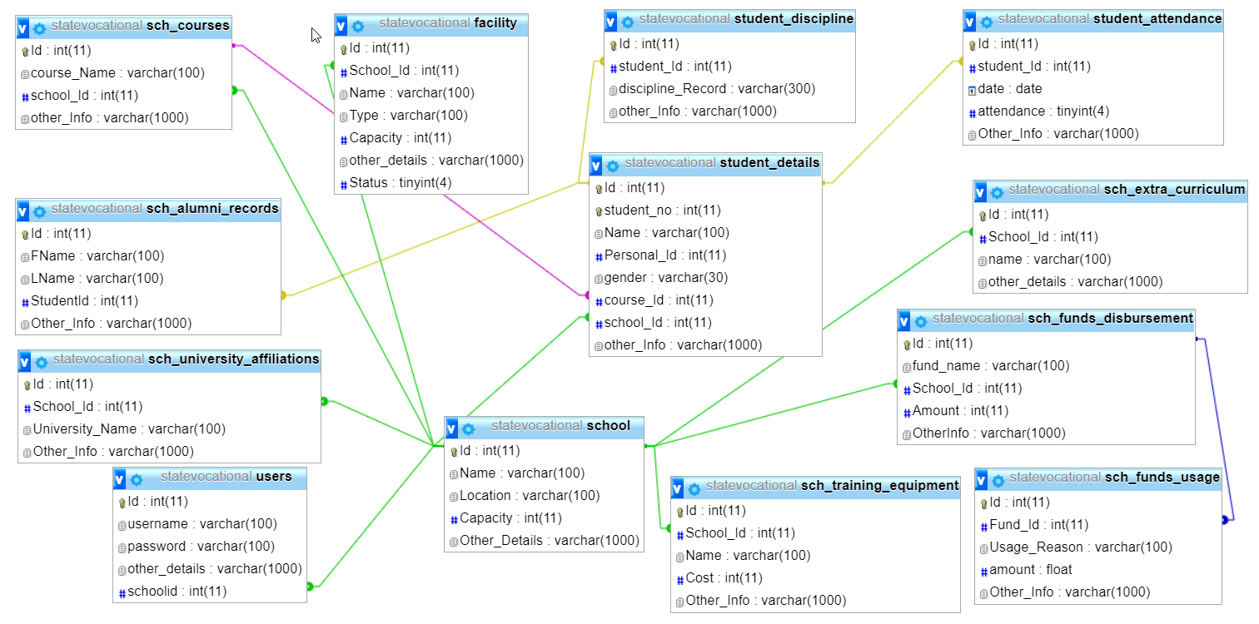

*A diagram of the database diagram for state vocational and technical education system*

The database design diagram can be described below:

The school table consist of the columns: Id, name, location, capacity, and other_details. The primary key for the table is id. The name column is a unique column in the table.

The student_details table consists of the following columns: Id, student_no, Name, Personal_Id, gender, course_Id, school_Id and other_Info. The primary key for the table is Id. The columns course_Id and school_Id are foreign keys representing tables Courses and School respectively.

The users table consists of the following columns: id, username, password, other_details and schoolid. The primary key for the table is Id. The column schoolid is a foreign key representing table school.

The sch_courses table consists of the following columns: Id, course_Name, school_Id and other_Info. The primary key for the table is Id. The column school_Id is a foreign key representing table school.

The sch_extra_curriculum table consists of the following columns: Id, name, other_details and School_Id. The primary key for the table is Id. The column School_Id is a foreign key representing table school.

The sch_training_equipment table consists of the following columns: Id, Name, Cost, Other_info and School_Id. The primary key for table is Id. The column School_Id is a foreign key representing table School.

The facility table consists of the following columns: Id, Name, Type, Capacity, Other_details, Status and School_Id. The primary key for table is Id. The column School_Id is a foreign key representing table School.

The sch_university_affiliation table consists of the following columns: Id, university_Name, Other_details and School_Id. The primary key for table is Id. The column School_Id is a foreign key representing table School.

The sch_funds_disbursement table consists of the following columns: Id, fund_Name, Amount, OtherInfo and School_Id. The primary key for table is Id. The column School_Id is a foreign key representing table School.

The sch_funds_usage table consists of the following columns: Id, Fund_Id, usage_reason, amount and Other_Info. The primary key for table is Id. The column Fund_Id is a foreign key representing table sch_funds_disbursement.

The sch_alumni_records table consists of the following columns: Id, FName, LName, StudentId, and Other_Info. The primary key for table is Id. The column StudentId is a foreign key representing table student_details.

The student_attendance table consists of the following columns: Id, student_Id, date, attendance and Other_Info. The primary key for table is Id. The column student_Id is a foreign key representing table student_details.

# **PRODUCT IMPLEMENTATION**

**PRODUCT EVALUATION**

**CONCLUSIONS AND RECOMMENDATIONS**

**ETHICS**

**REFERENCES**

**APPENDIX**